**Chips (Year 1) Assignment**

**Names in Group:** Clay, Ben, & Evan

***Part 1***

1. List 3 things that caused the poor performance.

|  |
| --- |
| **Causes of Poor Performance** |
| 1. Days of Accounts Payable decreased from 48 to 10, ultimately leading to less cash. |
| 1. They expected to sell 4% more cookies in 2020 but sold 7.27% fewer cookies than the previous year. |
| 1. Ineffective use of the increase in the marketing budget. |

1. List 3 things that were favorable for the year.

|  |
| --- |
| **Favorable Aspects of the Year** |
| 1. Inventory was reduced, giving them more cash to work with. |
| 1. We were able to decrease our fixed cost by $35,000. |
| 1. Current Liabilities were decreased. |

1. Create a proforma balance sheet (Proforma 1) with A/R and Cash correctly restated to reflect the 3-day delay in receiving cash from the credit card processors. Show the Current Assets section of the Proforma 1 balance sheet.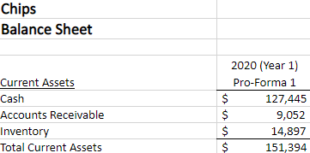
2. Using the new proforma (Proforma 1), calculate the number of days of cash for expenses that Chips had on hand at the end of 2020.  Show the calculations. Comment on the number of days of cash on hand.



**Part 2**

1. What happened to A/P in 2020 as compared to 2019? Comment on the difference and the impact of the change.

**We started taking the discount from our suppliers, causing the A/P to be lower. This led to less available cash on hand. This caused the Days of A/P to go from 48 to 10.**

1. Using Proforma 1, create and show a new proforma (Proforma 2) income statement and balance sheet based on the potential changes to working capital management.

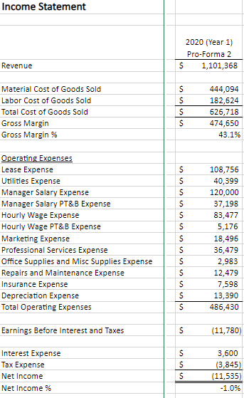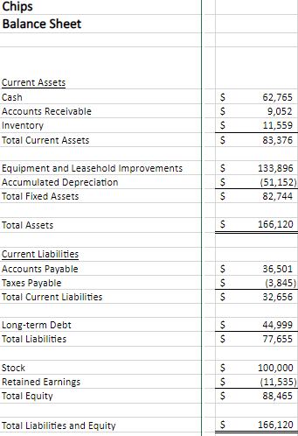

1. List the key assumptions made in the creation of Proforma 2.

|  |
| --- |
| **Key Assumptions** |
| Days of accounts payable can be reverted to how it was in 2019. |
| Inventory can be reduced to an even lower amount than it already has. |
| It’s possible to still operate without relying as much on creditors and investors. |

1. List 3 other potential areas of improvement.

|  |
| --- |
| **Potential Areas of Improvement** |
| 1. Even though we spent more on marketing, we sold fewer cookies compared to the previous year. A better implementation of the budget would bring in more customers. |
| 1. Revenue decreased while labor costs increased going into 2020. A more efficient plan for labor costs and total hours worked could save the company money. |
| 1. Make a consistent effort to monitor working capital. By doing so the company will have a better handle on its available cash. |